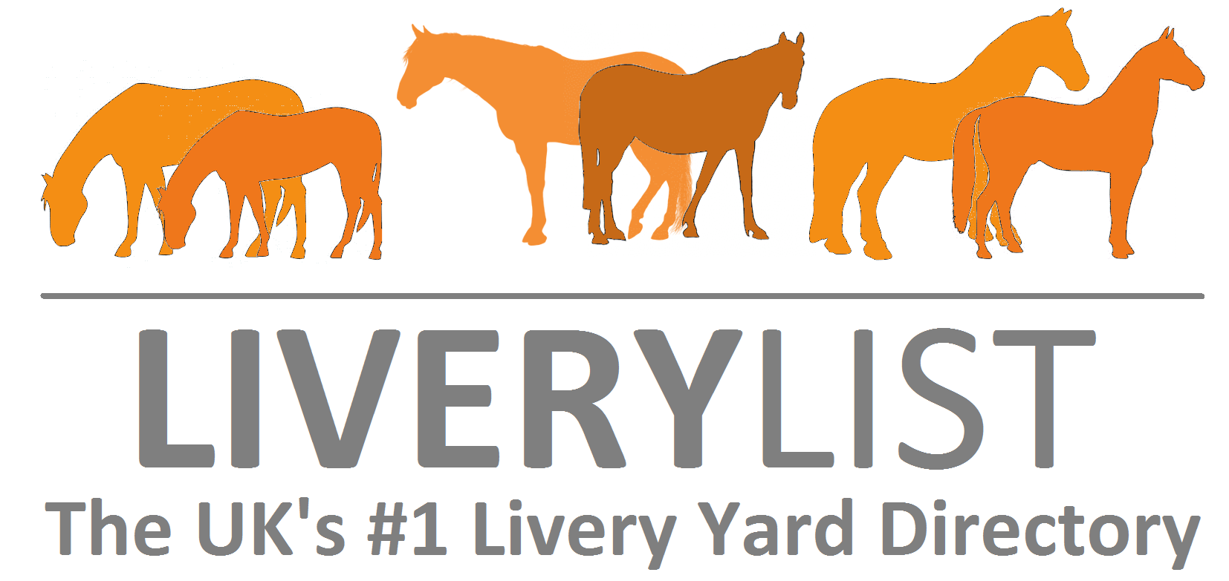

Sample Deposit Receipt
The form as shown below is a guide as to the type of receipt which you can request in the event that you pay a deposit or part balance of a horse.

This would be recommended in all cases where is a deposit is paid so as to confirm receipt of payment by the vendor and as confirmation s to the agreed price for the horse. The sample form should be edited to reflect correct information and agreements as made between the vendor and purchaser.

When amended and completed with your own particulars and signed by both parties it will form a legally binding agreement.

--------------------------------------------------------------------------------

This agreement is made on the (Insert Date) between the parties (Insert Purchaser Name & Address) (hereafter referred to as the PURCHASER) and (Insert Vendor’s Name and Address) (hereafter referred to as the VENDOR) with regards to the sale of (insert name of horse followed by brief description - e.g.Donny- 16.2 hand high bay gelding aged 15years approx. with white blaze and white sock) (hereafter referred to as the HORSE.)

The VENDOR confirms that they have received a deposit sum of (Insert sum in £) from the PURCHASER. It is agreed that the remaining balance of (Insert sum in £) shall be due to the vendor upon collection/ delivery and receipt of the animals passport (Delete as appropriate).

In the event that for any reason the PURCHASERS do not complete the purchase the VENDOR reserves the right to retain all, or a portion of the deposit payment at their discretion (Amend as appropriate).

Signed

……………………………………................. (THE VENDOR’S NAME PRINTED HERE)

…………………………………….......... (THE PURCHASER’S NAME PRINTED HERE)

IMPORTANT
This information as provided above is intended to provide guidance and areas for consideration for those intending to enter into such arrangements. Anyone proposing to enter into such a written agreement should take consideration and their own legal advice as to their particular circumstances.
© Livery List 2017

