CAREERS-BASED QUIZZES AND QUESTIONNAIRES
2022
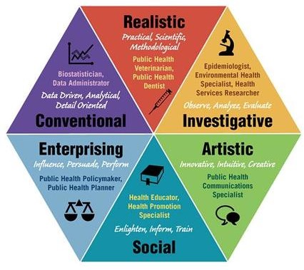

www.prospects.ac.uk – Looking for that perfect career? Match your skills and personality to 400+ job profiles - Career Planner
nationalcareers.service.gov.uk - Skills Assessment - Discover your skills and careers / Skills Health Check
www.ucas.com – Career quiz - Find your ideal career
www.icould.com -Buzz Quiz
www.careerpilot.org.uk – Career Pilot job sector quiz / Careerpilot Skills Profile / Buzz Quiz (as above) / SACU Spartan test / Career Planner (as above)
www.getmyfirstjob.co.uk – Career Quiz
www.healthcareersnhs.uk – NHS Health Careers Quiz

********************************************

