WHAT CAREER LIVE? / WHAT UNIVERSITY LIVE? VIRTUAL EVENT – MARCH 2021

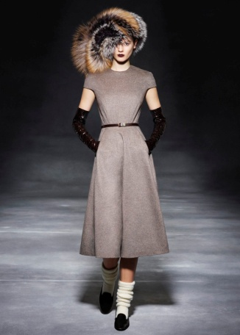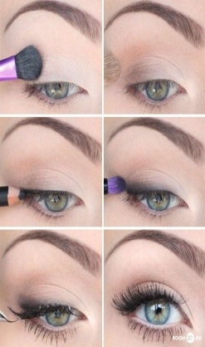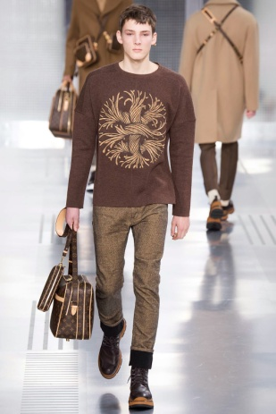

FROM DESIGN TO MAKE UP – THE FASHION JOURNEY HAS SOMETHING FOR EVERYONE webinar
This is a vast industry, more than you may think! It is the time for you to be part of the evolution, innovation and reinvention of the industry! As we are moving towards a post covid life, the world has changed and so has the industry.
The UK fashion industry is worth nearly £30 billion to the UK economy...now is the time to be creative!
Fashion is a major UK employer with nearly 900,000 jobs across the sector – and is also the largest creative industry in the UK.
Many jobs have been lost in the retail sector during the pandemic, as we know, but this area WILL be reinvented with more online prospects.

Where do you fit in?
- Do what you love – you will be doing it for the rest of your life, maybe!...hopefully!
- Your love of fashion shouldn’t be 1- dimensional – there are MANY different paths

Design – careers still exist in fashion design, textiles, all sorts of combinations. Many graduates will decide to go self employed, have their own business and some will enter careers such as in buying, PR, fashion illustration to name just a few possibilities.
If you are NOT a “maker”....then consider being a creative visual learner (CVL), a creative visual and written communicator (CVWC), more business minded or think more about the creative arts (CA):-
CVL – Fashion stylist? Creative director?
CVWC – Fashion media consultant? Beauty promoter? Fashion journalist?
CA - Make-up and hair designer? Prosthetics and special effects designer?

Advice
Imagine yourself in 5 years time...................what does your day look like?.................are you working in an office or are you working away from home?...........are you a freelancer or are you working alongside others, in a team?.........do you dress up or dress down? (either is fine!)........are you more a creator or a facilitator?............................

AMANDA WATSON
CAREERS ADVISER
MARCH 2020

