WHAT CAREER LIVE? / WHAT UNIVERSITY LIVE? VIRTUAL EVENT – MARCH 2021

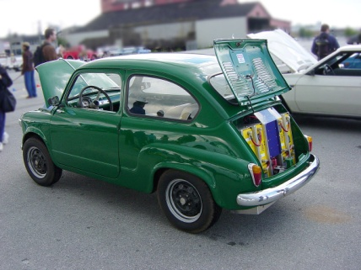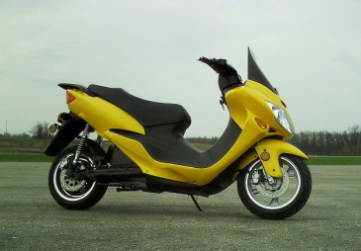

Careers in the Automotive industry webinar – by the IMI (Institute of Motor Industry)

- Careers cover everything from a vehicle leaving a manufacturing to being scrapped
- Industry influences everyone such as travelling to work and the emergency services
- It is an industry that helps keep the country moving
- 160 roles – includes sales/leasing/maintenance and repair/ parts/ service advice/ management/business and more
- It is a growing industry due to new demands for electric/ autonomous vehicles – it is constantly innovating – all new vehicles due to be electric by 2030

IN NUMBERS
- 8 major premium and sports cars manufacturers
- 6 Design Centres
- 9 Bus and Coach manufacturers
- 60+ specialist car manufacturers
- 2,500 suppliers
- 9 Engine manufacturers
- 5 commercial vehicle manufacturers
- 20 R&D centres
......................and there’s more.....................
- £82 billion turnover in UK
- 2,540, 617 new cars registered in 2017
- 856,000 employed across UK Auto

There are currently 34.7 million cars on UK roads!
Autonomous vehicles – Robotic age / highly automated / drone taxis / E pods / E scooters and bikes
Connected – V2X / Smart City / Smart cars / Smart home / Smart living
Electric vehicles – electric everything – cars/trucks/motorcycles/ buses and coaches
STEM subjects most useful - important at GCSE level and most careers post 16 – other subjects are also useful, though, such as Computer Science, Art and Design, Business and Economics.
Useful skills?
- Drive and ambition
- Willingness to challenge yourself
- Problem solving
- Dynamic
- Curiosity
- Teamwork
- Able to follow instructions
- Communication skills

Apprenticeships and University – personal choice
54% of all apprenticeship starts were women (2016/17) – but only 6% of engineering apprenticeships are filled by females. More businesses are employing more women in senior positions.

For more information, visit tide.theimi.org.uk

AMANDA WATSON
CAREERS ADVISER
MARCH 2021

