UK UNIVERSITY & APPRENTICESHIP SEARCH VIRTUAL FAIR – MARCH 2021

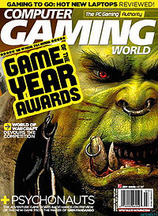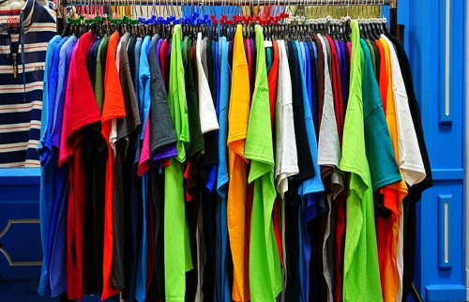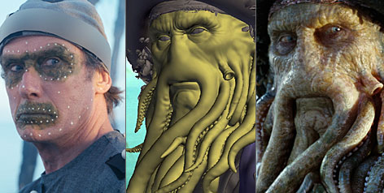

INTRODUCTION TO CREATIVE CAREERS webinar
What are creative careers?....many initially just think of fine art, art and design...and that is dismissing a huge number of opportunities... creativity is all around us...think of your house and what’s in it...the furniture, the interiors, the clothes in your wardrobe, the games devices, the technology in your mobile phone, your TV/s, the building itself....
The value of the creative industries may surprise you...
.....£115.9 billion pound a year in UK in 2019
.....2.1 million jobs in UK in 2019
.....5.6% increase in value since 2018
.....64.2% of those working in creative industries have a degree – stresses the importance of higher education to the creative sector
.....46% of these above are working in the creative field, 82% in design, 75% in architecture
.....52% of creative graduates work in the creative industry
.....88% are employed within a creative career 3 and a half years after graduating
.....28.1% of creative graduates work freelance or have their own business
(UK Creative Industries)

The pandemic has obviously had some impact on the industry – there has been a £29 billion pound loss in 2020 (down by 26%) with up to 1 in 5 creative jobs lost

The largest sector within the UK is in games software and this has grown during the pandemic – not a surprise?! Indeed, it has been the fastest rate of increase in more than a decade
Other pandemic facts of interest:-
- there has been more opportunities to work flexibly and remotely
- it has boosted accessibility and inclusivity
- the UN has dedicated 2021 as the International Year of the Creative Economy for Sustainable Development

Everyone who works within a creative career has “a passion” – is this you?? What have you done over the lockdowns?? Have you been playing computer games? Designed any? Watched movies? Used various technology? Listened to music? Picked up any new hobbies?...amongst other things...

Key skills – there are many invaluable transferable skills in all creative based degrees (such as practical skills, literacy, numeracy, communication, commercial awareness, use of technology, critical analysis and others) – creative degrees DO NOT limit you – as stated, many can work freelance, to fill in any gaps in your working life/career too...

There are MANY different degrees out there so check them out! They can lead you into different careers too!

Think about what you are doing now and what you LOVE – is it drawing? (illustration, animation, art therapy careers, for example). Is it more 3D? (interior design, architecture and others)

Question: How do you convince parents / carers who may be sceptical about you making any career in the creative industry?
Answer: Take parents to events like this! Campus tours, departmental visits and so on. Show them the facilities (many “state of the art”, highly advanced technology used)...let them talk to academics....show them the extent to what is possible! Get them informed – they may change their minds

AMANDA WATSON
CAREERS ADVISER
MARCH 2021

