Advanced Rosette Programme
Building confidence, knowledge and responsibility through horses
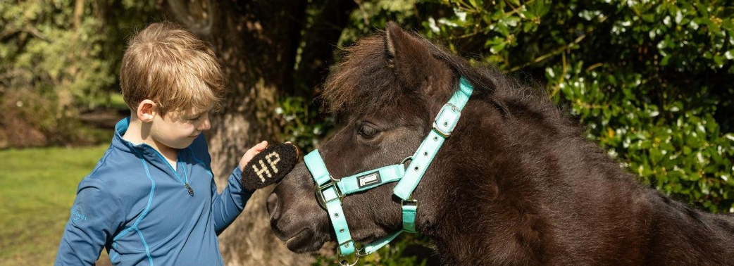
A Non-Ridden, Hands-On Learning Experience
Our Advanced Rosette programme is entirely ground-based and focuses on:

- Observing horse behaviour
- Safe handling and interaction
- Horse care and yard routines
- Structured, practical activities

Learners develop understanding through doing—not just watching.
Structured Learning, Not Just Time with Horses
Each Rosette is delivered through a clear framework:
Learn → Observe → Do → Reflect
Sessions are purposeful, progressive and designed to build real skills and understanding.
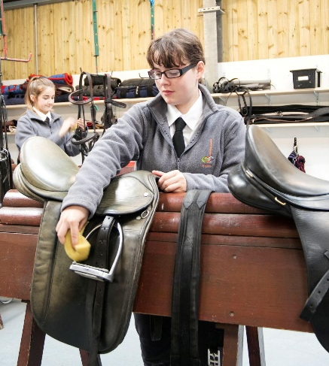
Why Working with Horses Supports Learning
Horses respond directly to human behaviour, body language and attention, providing immediate and consistent feedback.
This helps learners to:
- Develop self-awareness
- Improve focus and behaviour
- Build calm, consistent approaches
- Understand cause and effect in real time
Practical tasks and routines further support engagement, organisation and confidence.
Supporting the National Curriculum
Sessions are designed to complement key areas of learning:

- Science – behaviour, care and welfare
- PSHE – responsibility and self-management
- Communication – listening and discussion
- Mathematics – measuring, quantities and routines

A Recognised Framework

Based on a nationally developed programme from Association of British Riding Schools, affiliated to and informed by the Equine Assisted Services Partnership.
What Young People Gain
Equine Skills

- Understanding behaviour and responses
- Safe handling and interaction
- Practical care and routines

Transferable Skills

- Confidence and independence
- Responsibility and accountability
- Communication and teamwork
- Focus and organisation

Developing Behaviour & Self-Regulation
Working with horses requires calm, consistent behaviour.
Learners quickly see how their actions influence outcomes, helping them to:

- Adjust their responses
- Improve concentration
- Build confidence through success
Who It’s For
- Schools and Alternative Provision
- Home-educated learners
- Young people who benefit from practical learning
Particularly effective for those who:
- Struggle in classroom settings
- Need structure and clear expectations
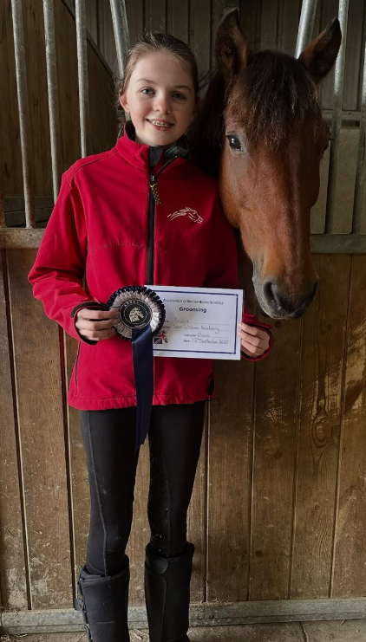
- Engage better through hands-on activity
Flexible Delivery
We offer:
- Short-term placements
- Term-based programmes
- Bespoke packages linked to individual outcomes
Suitable for SEND, AP and engagement programmes.
Clear Progression
- Structured pathway
- Ongoing feedback
- Recognised Rosette awards
Find Out More
[Yard Name]
[Contact Details]
[Website]

