Extreme Weather Procedure
Purpose
This policy outlines the procedures for managing horse welfare and rider safety during periods of extreme weather, including heat, cold, storms, flooding and drought. It ensures that the riding establishment takes reasonable and proportionate steps to protect animals and people, in line with statutory duties and best practice.
Scope
Applies to all:
- Ridden lessons, treks and day rides
- Groundwork and stable management sessions
- Horse handling and care activities
- Staff-led and client-facing operations
General Principles
- Horse welfare takes precedence over commercial or scheduling pressures.
- Decisions should be based on a dynamic risk assessment that considers both environmental factors (temperature, humidity, workload, air movement) and individual horse factors (age, fitness, body condition, pre-existing conditions, etc) rather than temperature alone.
- Rider welfare should be assessed alongside horse welfare, as riders may be more susceptible to heat-related illness than horses.
- Weather-related decisions should be proportionate and evidence-based, recognising that horses are generally well adapted to hot environments but that strenuous exercise and high humidity can significantly increase risk.
Hot Weather Management
- Background. Horses are naturally adapted to hot climates and possess highly effective cooling mechanisms based primarily on sweating and evaporation. Heat-related illness is more commonly associated with strenuous exercise than environmental temperature alone. Risk increases where humidity is high, temperatures approach normal body temperature (approximately 38°C), air movement is limited, or where an individual horse has a reduced ability to sweat (anhidrosis).
- Risk Management Approach. The hot weather guidance below should form the basis of a dynamic risk assessment rather than be used as a simple temperature cut-off. Before activities commence, staff should consider ambient temperature, humidity, wind or air movement, time of day, availability of shade and water, cooling facilities, workload, rider factors and the needs of individual horses.
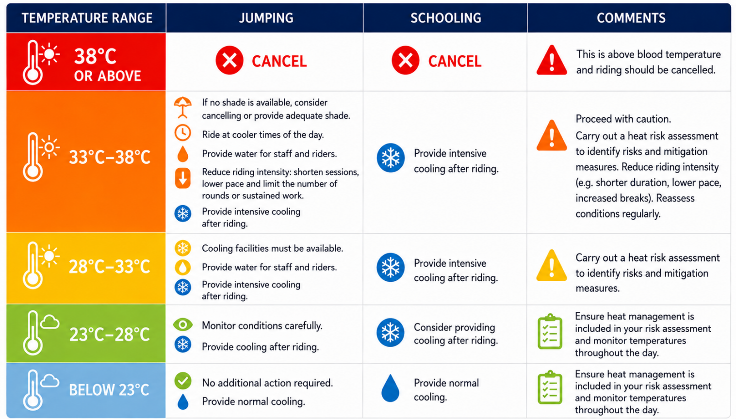
Preventative Measures:
- Monitor daily weather forecasts (for example, the Met Office app), including both temperature and humidity.
- Schedule strenuous work during cooler parts of the day where practicable.
- Ensure continuous access to clean drinking water and shade.
- Delay tacking up until immediately before work to minimise unnecessary heat retention.
- Modify workload, lesson duration or intensity according to the dynamic risk assessment.
- Provide prompt cooling after strenuous exercise whenever horses are sweating.
Cooling After Exercise
Cooling should begin promptly after strenuous exercise. Apply repeated volumes of cool (not ice-cold) water to the major muscle groups while continuing to walk the horse where safe to do so. Air movement increases evaporative cooling and should be encouraged. Continue cooling until breathing and body temperature have returned towards normal. Routine scraping of water is unnecessary while active cooling is continuing.
Additional Risk Factors
- Older horses, overweight horses, dark-coated horses and those with underlying health conditions may require additional restrictions.
- Horses suspected of suffering from anhidrosis should be assessed by a veterinary surgeon before undertaking work in hot weather.
- Where humidity is particularly high or environmental temperatures approach or exceed 38°C, activities should be significantly modified or cancelled.
Signs of Heat Stroke
- Early Signs of Heat Stroke:
  - Fast or heavy breathing, without improvement.
  - Excessive sweating.
  - Increased heart rate.
  - Tiredness or weakness.
  - Muscle stiffness or shaking.
- Advanced Warning Signs:
  - Raised rectal temperature of above 38°C.
  - Lack of sweating (anhidrosis).
  - Staggering, wobbling, or loss of coordination.
  - Dark or discoloured gums.
  - Laboured or difficult breathing.
  - Attempting to lie down or collapse.
If any of these signs are present, act immediately: move the horse to a shaded area, begin active cooling with water, keep them walking, and contact a vet for advice.
Cold Weather Management
Risk Factors
Horses can generally tolerate cold temperatures well. However, when the temperature drops below freezing (0°C), and especially when it is combines with wind and wet, the risk of cold stress increases. If the temperatures drop significantly below freezing (e.g., -10°C or lower), and especially if combined with high winds or wet conditions, it is considered extreme cold weather. In such conditions, special attention to horse care is crucial.
Protective Measures
When the weather is likely to be cold, daily checks using AI-assisted weather apps or smartphone meteorology tools. (The Met Office App provides expected temperature).
In extreme cold weather, horses will be protected through:
- The provision of adequate shelter, either using stables or the provision of wind breaks to reduce wind chill. Stables are to be provided with ample, clean bedding to provide insulation from the cold floor
- The use of appropriate rugging. The table below provides a guide on the weight of rugs to be used:
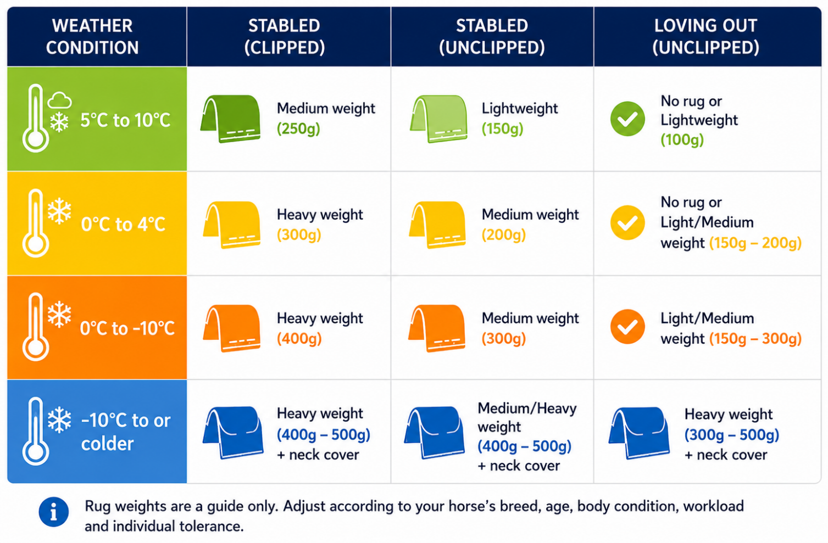
- Body condition should be monitored and feed adjusted to maintain healthy weight.
- Water sources should be checked regularly to ensure they are unfrozen. Taps should be insulated and defrosted as needed.
Flood Management
In the event of flood warning or floods, horses should be stabled and prevented from drinking flood water, which may be contaminated with sewage, manure and chemicals. If it is believed that horses may have drunk the water, contact the vet for guidance and advice.
If floods risk the lives of the horses, the Emergency Evacuation Plan should be implemented.
Drought Management
A Temporary Use Ban (TUB) imposes restriction on the use of water when the availability of water is poor (normally because of drought conditions). Even when a TUB has been declared, taps and hosepipes can continue to be used to provide water for horses for drinking and cleaning.
Staff are to ensure that horses always have access to fresh, clean water to prevent dehydration. However, staff are to use water sparingly and only to empty water barrels, troughs, buckets if fouled by manure or urine.
Monitoring and Communication
- The establishment should subscribe to Met Office and Environment Agency alerts.
- Weather warnings should be reviewed for impact likelihood and guidance.
- Graduated responses should be communicated to staff and clients via email, text, social media, and verbal briefings.
- Cancellations or changes to the riding schedule should be published in sufficient time for clients/riders to amend their plans.
- This policy should be distributed to clients at the start of summer.
Staff Responsibilities
- Yard Manager or designated senior staff should monitor weather and make daily decisions.
- All staff must be trained to recognise signs of heat/cold stress and dehydration.
- Water consumption should be monitored, especially for stabled horses.
- Hydration checks should include skin pinch tests, gum colour, and heart rate.

