Client Weighing and Horse Carrying Capacity Policy

Purpose and Welfare Rationale
The purpose of this policy is to ensure that no horse or pony is required to carry a rider whose weight, relative to the animal’s size, condition, fitness, and conformation, could compromise its health, comfort, or welfare.
The policy is framed entirely as an animal welfare measure, not as a judgment of riders’ bodies. It safeguards horses from preventable strain, injury, or distress, in accordance with the Five Domains of Animal Welfare and the First Principles of Horse Training.
Policy Statement
- We are committed to the highest standards of horse welfare, rider safety, and inclusivity.
- Each horse has a defined weight-carrying range based on veterinary, physiotherapy, and coaching input.
- Horses and ponies will not be worked beyond these limits.
- All weighing procedures are handled confidentially, respectfully, and with consent.
- Discussions with clients, especially children, are always framed around protecting the horse’s welfare and maintaining a positive experience for the rider.

Welfare Basis for Weight Assessment
Evidence from welfare organisations (e.g. World Horse Welfare, Hartpury research) indicates that most horses should not routinely carry more than 15–20% of their body weight, including tack.
Factors considered include:
- Horse’s size, age, fitness, breed, and conformation
- Rider’s balance, experience, and fitness
- Duration, type, and intensity of work
- Fit and weight of tack
- Ongoing welfare observations (behaviour, gait, back condition)

Implementation
- Rider Weight Recording
  - Clients are asked to provide their approximate weight range on registration to ensure appropriate horse allocation. This should include hats, riding boots and body protector (if worn).
  - Where a rider may be near the upper limit for available horses or where there is significant doubt about the rider’s estimate of their weight, they may be invited to use the school’s modified weighing scales for an accurate assessment. These have been modified to remove the numeric weight and to replace these with colour banded weight ranges.
  - Weighing is conducted:
  - Privately,
  - Voluntarily, and
  - With the client’s or parent’s consent (for minors).
  - Our records will be updated annually.
  - All information is treated as confidential and stored in accordance with GDPR.
- Horse–Rider Matching
- Horses are matched to riders according to welfare and safety considerations. The maximum weight a horse can carry will be matched to the colour banding on the modified weighing scales.
- Where a suitable horse is unavailable, the following alternatives may be offered:
  - Groundwork or unmounted learning sessions
  - Participation in stable management or horse care lessons
  - Placement on a waiting list until a suitable horse becomes available
  - Referral to another licensed establishment with appropriate horses

Children and Young Riders
Children’s involvement in riding brings unique considerations for safety, welfare, and wellbeing. This policy applies the following additional principles:
- Weight and balance assessments for children focus on proportion and coordination, not solely on weight.
- Staff will never weigh a child without parental knowledge and consent.
- Discussions about weight are handled with parents or guardians, not directly with the child, unless appropriate for age and understanding.
- Conversations are framed around the needs of the pony, e.g.:
“This pony is most comfortable with smaller riders — let’s find one that’s a better match for your child.”
- No child will be made to feel embarrassed or excluded.
- Alternative riding activities such as lead-rein sessions, balance games, or groundwork are always offered to maintain inclusion and confidence.
- Staff follow the school’s Safeguarding and Equality Policies in all communications.

Communication and Sensitivity
- The policy is introduced to clients and parents as a routine welfare measure to ensure the comfort and safety of horses and riders.
- All staff receive training in sensitive communication to ensure consistency and professionalism.
- Language focuses on animal comfort and rider development, not physical appearance or weight.
- Any concerns raised by clients are managed by the Yard Manager .

Responsibilities
Role | Responsibility
Proprietor / Yard Manager | Ensure compliance with welfare legislation and licensing conditions
Coaches | Allocate horses appropriately and monitor for welfare issues
Staff | Maintain confidentiality and support sensitive communication
Staff | Apply the policy consistently and respectfully
Clients / Parents | Provide accurate information and cooperate with welfare-based decisions

Record Keeping
- Each horse’s assessed weight-carrying capacity is recorded in its Horse Assessment Form.
- Records of rider weight assessments (if completed) are held confidentially and used solely for welfare matching. The actual weight will not be recorded – just the colour code.
- Welfare reviews and any decisions regarding unsuitable matches are documented.

References
- Animal Welfare Act 2006
- Animal Welfare (Licensing of Activities Involving Animals) Regulations 2018 – Schedule 5
- DEFRA Code of Practice for the Welfare of Horses (2017)
- ABRS+ & World Horse Welfare Rider Weight Guidelines
- BEF Safeguarding and Equality Policies

Appendix - Modified Weighing Scales and Horse Weight Banding

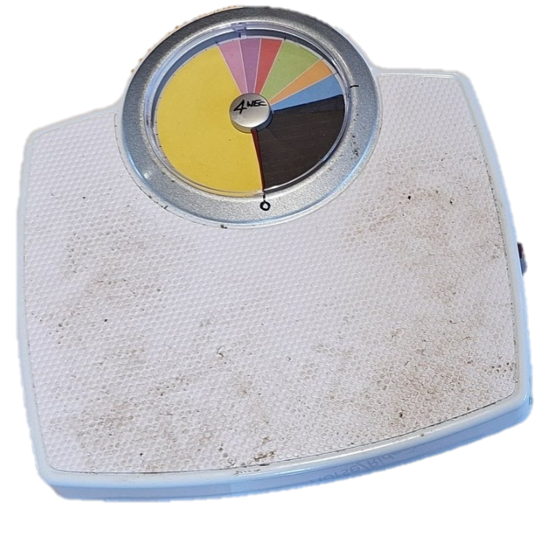

Modified Weight Scales

Up to 60kg | Up to 65kg | Up to 70 kg | Up to 75Kg | Up to 80 kg | Up to 85 Kg | Up to 90 Kg
Billy | Jim | Winnie | Robin | Apollo | James | Hercules
Bob | Domino | Will | Rosie | Larry | H | Mike
Horse Weight Chart

