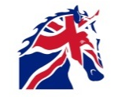
TACK CLEANING & INSPECTION FORM
Dental Check and Treatment Record

Horse’s Name
Horse should have a dental assessment annually; this should be undertaken by a qualified Vet or Dental Technician (EDT) who is registered with the British Association of Equine Dental Technicians (BAEDT) (http://www.baedt.com) or Category 2 members of the World Wide Association of Equine Dentists (WWAED) (http://wwaed.org.uk/wwaed-category-2-list). Equine Dental visits should be recorded below.
EDT  Visit Date | EDT Name | Reason for Visit  (Annual, Treatment etc) | Comments | Name & Signature

